Software Requirements Specification

for

<Seller’s Credibility List>

Version 1.0 approved

Prepared by <Group No. 3>

<Section No. 4>

<14-10-2021>

Table of Contents

Table of Contents ii

Revision History ii

1. Introduction 1

1.1 Purpose 1

1.2 Document Conventions 1

1.3 Intended Audience and Reading Suggestions 1

1.4 Product Scope 1

1.5 References 1

2. Overall Description 2

2.1 Product Perspective 2

2.2 Product Functions 2

2.3 User Classes and Characteristics 2

2.4 Operating Environment 2

2.5 Design and Implementation Constraints 2

2.6 User Documentation 2

2.7 Assumptions and Dependencies 3

3. External Interface Requirements 3

3.1 User Interfaces 3

3.2 Hardware Interfaces 3

3.3 Software Interfaces 3

3.4 Communications Interfaces 3

4. System Features 4

4.1 System Feature 1 4

4.2 System Feature 2 (and so on) 4

5. Other Nonfunctional Requirements 4

5.1 Performance Requirements 4

5.2 Safety Requirements 5

5.3 Security Requirements 5

5.4 Software Quality Attributes 5

5.5 Business Rules 5

6. Other Requirements 5

Appendix A: Glossary 5

Appendix B: Analysis Models 5

Appendix C: To Be Determined List 6

Revision History

|  |  |  |  |
| --- | --- | --- | --- |
| **Name** | **Date** | **Reason For Changes** | **Version** |
|  |  |  |  |
|  |  |  |  |

# Introduction

## Purpose

This SRS describes the software functional and nonfunctional requirements for Credible Seller’s list. This application will allow user to exchange products of various types where buyer will give credibility to the seller depending on the quality on of the product and other factors.

## Document Conventions

Headings are in bold

**Font**: Times new roman

**Size**: 12

Requirements are written in points.

## Intended Audience and Reading Suggestions

This document is intended to be used by members of the project team that will implement and verify the correct functioning of the system. This document is also to be used while explaining the client all the features and characteristics of the application.

## Product Scope

It is a web-based application that helps users to sell their products and buy from their credible friends/relatives. It will be easy to navigate based on the seller's credibility and user-friendly. The goal is to create a platform which is safe and reliable to use. It is also secure because a user needs to login and no unauthorized person can access an account.

## References

* Taking help from book for use case diagram
* <https://www.youtube.com/watch?v=zid-MVo7M-E&t=1s> for use case diagram

# Overall Description

## Product Perspective

The main goal of the product is to connect the buyers to the most reliable seller in their list. There are 3 main users of the product: sellers, buyers, admin. The product will be going to be user-friendly, where even unskilled person can also use it. It is web-based application which should run on browser. The product is not dependent on any other product.

## Product Functions

Functions of the product are:

1. Connecting the buyer to the best seller in their connections.
2. User can add their friend and family members by giving ratings accordingly
3. Buyers can see the pictures and description of the products.
4. User can select, how long the credible seller list they want.
5. Buyers will have the option to chat with the seller on the application.
6. Sellers can add more than one product at a time and only they have the option to delete the product.
7. Sellers can see the list of ads they have posted.
8. Sellers will have a 2-step confirmation before posting ads as they cannot edit/update it after posting.
9. If certain period has passed, so notify seller that your ad has been expired.
10. Both sides, will verify after the transactions has occur.
11. Allow the buyers to have an option of searching the product.
12. When buyers click on any product (to see the details), down on that window they will have option of new product of same category.
13. Buyers will also have an option of list where they can select the category of product they want to see.
14. Buyers will have an option to even see list from sub-category.
15. Buyers can update the seller credibility after the transactions.
16. Admin has rights to remove sellers on some policies.
17. Users can contact us through email, call or social media.
18. Admin will tackle with complain and guidance.
19. Buyer have an option to search the product from a particular area.
20. Users can filter out chats that are unread.
21. User will have the option to update and maintain their profile such as picture, location etc.
22. User will have an option to reset password if they forget.
23. If they added wrong password so error massage will display.
24. User will have the option to see notifications.
25. Buyers will have an option to mark/flag ads which they see to see again later.

## User Classes and Characteristics

There are 3 users of the product:

* Buyers

They can see the credible (which are given highest rating) seller list. These users will be ranging from above 18 to adult people to keep check of security levels. They will have a limited information of the seller (only place and phone number). Only this user is pertained to give rating to the seller they have interact.

* Sellers

They are added by their friends or family members. These users will also have the same range from above 18 to adult people for security. They are pertained to add more friends and family member in the list by giving them ratings. There is no requirement of education or any skill from sellers.

* Admin

These users will not run the application but only act as a moderator. They only have rights to remove the seller from the list if there rating is too low. They will investigate the complains if any of them come up. These people are skillful, who know how to use the technology and will be 3-4 years experienced people.

## Operating Environment

This product will function on two types of hardware platform, which are desktop and mobile. This will be a responsive web-based and mobile application which will run on browser, including both android and IOS. There also exist a database to store information, which will be used on MySQL.

## Design and Implementation Constraints

• Privacy policy because they are too complicated and time-consuming to implement. For example, if your app handles personal or sensitive user data, you have to disclose how you treat sensitive user and device data.

• Cookie management If you use cookies of user/buyer in your app, you’re required both by law and by law-abiding third-parties such as Google, Amazon, Apple, Facebook etc. to comply with legal requirements.

• Timing requirement: App should made within 3 months.

• Memory requirement: app should consume memory less than 100MB.

• There should be an API (Application Programming interface) that allows two user/buyer to talk to each other efficiently and to exchange data and functionality easily and securely.

• Web based app technology should be used having frontend of react/angular.

• Oracle/MySQL/MongoDB can be used as databases.

• HTML, CSS and JavaScript can be used as language requirements.

• Communication protocols: HTTP, HTTPS, FTP and IP etc.

• Security considerations: Encryption/Authentication.

• App developer will be responsible for maintenance.

## User Documentation

There will be a written documentation with pictures of user interface, which will help the user. There will be a user manual which is mandatory for every admin member to read. We will create a test for admin member at the time of hiring about user manuals.

We will be going to add a page of FAQs where the user can take guidance of common questions. User can take help by contacting our admin team, which is already trained.

## Assumptions and Dependencies

* The system will be running 24 hours a day.
* It will be dependent on internet connectivity as it will run on browser.
* The user will enter the correct login details.
* Users must have email address for login details.
* Responsive web design on both mobile and desktop is important else using the app would be difficult.
* Flawless user experience and navigation which makes app attractive.
* There can occur some scalability issues e.g., traffic managing in peak hours of app usage.
* Technology and framework’s version can become outdated.
* Bad performance can play a major part in app failure and can occur due to Poorly written code, Un-Optimized Databases, Unmanaged Growth of data, Traffic spikes, Poor load distribution, Default configuration, Troublesome third-party services, etc.
* Security is often neglected thus it should be considered throughout the software development life cycle, especially when the application is dealing with the vital information such as payment details, contact information, and confidential data.
* Some of the security threats which quite common are Cross-Site Scripting, Phishing, SQL Injection, Buffer Overflow, etc.

# External Interface Requirements

## User Interfaces

<Describe the logical characteristics of each interface between the software product and the users. This may include sample screen images, any GUI standards or product family style guides that are to be followed, screen layout constraints, standard buttons and functions (e.g., help) that will appear on every screen, keyboard shortcuts, error message display standards, and so on. Define the software components for which a user interface is needed. Details of the user interface design should be documented in a separate user interface specification.>

## Hardware Interfaces

<Describe the logical and physical characteristics of each interface between the software product and the hardware components of the system. This may include the supported device types, the nature of the data and control interactions between the software and the hardware, and communication protocols to be used.>

## Software Interfaces

<Describe the connections between this product and other specific software components (name and version), including databases, operating systems, tools, libraries, and integrated commercial components. Identify the data items or messages coming into the system and going out and describe the purpose of each. Describe the services needed and the nature of communications. Refer to documents that describe detailed application programming interface protocols. Identify data that will be shared across software components. If the data sharing mechanism must be implemented in a specific way (for example, use of a global data area in a multitasking operating system), specify this as an implementation constraint.>

## Communications Interfaces

<Describe the requirements associated with any communications functions required by this product, including e-mail, web browser, network server communications protocols, electronic forms, and so on. Define any pertinent message formatting. Identify any communication standards that will be used, such as FTP or HTTP. Specify any communication security or encryption issues, data transfer rates, and synchronization mechanisms.>

# System Features

***Overall use case diagram:***

**4.1 System Feature 1**

**Web based and mobile Application**

4.1.1 Description and Priority

The application will be a desktop based as well as mobile friendly. No memory will be required while accessing through web browser however some memory will be required for mobile application.

Priority: High

4.1.2 Stimulus/ Response

Not Applicable

4.1.3 Functional Requirements

Not Applicable

**4.2 System Feature 2**

**Customer Profile**

4.2.1 Description and Priority

To post ads user need to create an account or already have an account by another user.

Priority: High

4.2.2 Stimulus/ Response

Stimulus: User requests to post an ad

Response: system asks user to login or signup

Stimulus: User will request login in case where the user already have an account or signup to create an account.

Response: system will verify credentials in the database or add new record to the database to allow user to proceed with posting ads.

4.2.3 Functional Requirements

Sellers need to have an account

Sellers can post any ad of any category and can post more than one ad at a time.

|  |  |
| --- | --- |
| Use Case name | **Log In** |
| Related Requirements | Table 1 |
| Goal in context | User allowed to get into their account |
| Preconditions | User must already have an account  User also have same email address |
| Successful end Condition | User can successfully login into their own account with home page loaded. |
| Failed End condition | User can’t login into account, even with their right credentials. |
| Primary Actor | User |
| Secondary Actors | database |
| Trigger | Log In button pressed by user. |
| Included Cases |  |
| Main flow | 1. User will enter their details like email address or username and password.  2. Database will check if record exists.  3. Database will check if the credentials are rightly matched.  4. If credentials not matched so clicked forget password and OTP will be send so they can reset the password.   1. Otherwise, clicked LogIn button and you will be into your account. |

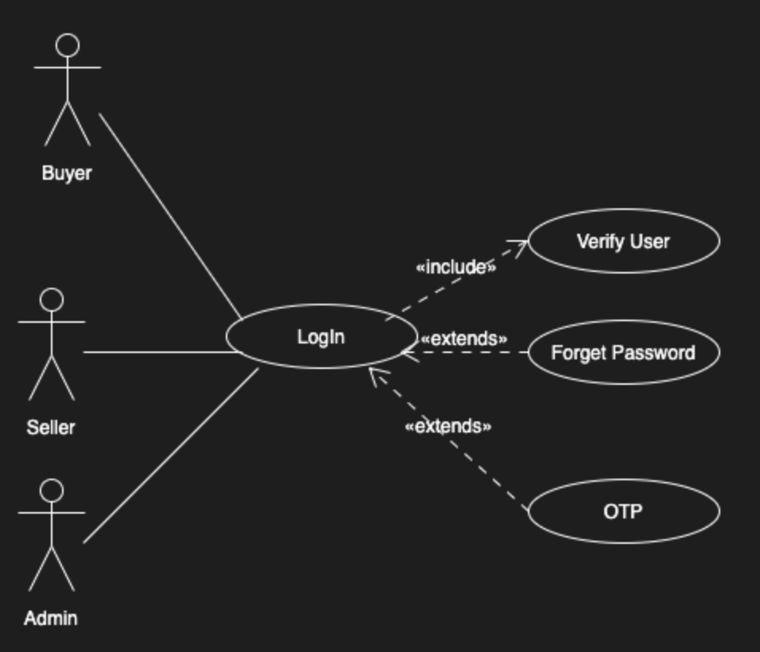

|  |  |
| --- | --- |
| Use case name | **OTP / Email Verification** |
| Related requirements | Table 2 |
| Goal in context | User Sign up successfully |
| Precondition | User must have an email id |
| Successful End Condition | Successful sign up |
| Failed End conditions | User sign up denied |
| Primary Actor | User |
| Secondary Actor | None |
| Triggers | User will click on the button for sign up after giving his/her credentials |
| Included Cases | Verify account |
| Main Flow | 1. User enters credentials and enters sign up button 2. An OTP is sent to the User’s email 3. The system displays Enter OTP screen 4. User enters the OTP 5. The system crosschecks the entered OTP with the generated OTP 6. If the OTP is correct, system displays Successful sign up otherwise incorrect OTP message will appear |

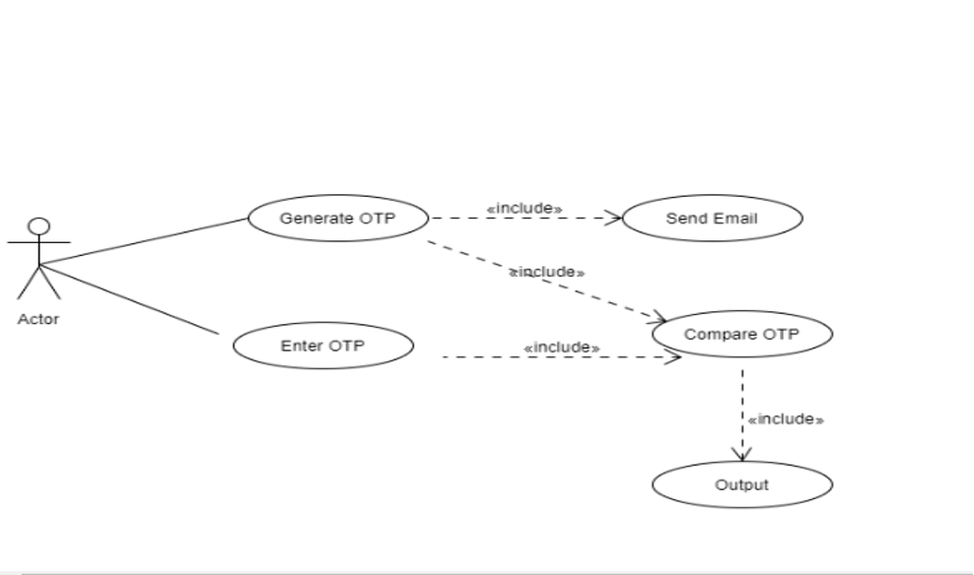

|  |  |
| --- | --- |
| Use case name | **Forget Password** |
| Related requirements | Table 3 |
| Goal in context | User forgets the password and recover it from this |
| Precondition | User should have a existing account |
| Successful End Condition | User logged into the system after recovering the password |
| Failed End conditions | System denies the password and user is unable to login |
| Primary Actor | User |
| Secondary Actor | None |
| Triggers | Users click on the forget password button |
| Included Cases | Verify account |
| Main Flow | 1. The user clicks the button for forget password 2. User is requested to enter his/her email on display 3. The user enters the email already registered before on the system 4. The system crosschecks the email and send an OTP to verify the email on the given email 5. User will enter the OTP 6. System will compare the OTP and will take user to a new display to enter new password 7. User enters the new password 8. Password successfully changed message will appear |

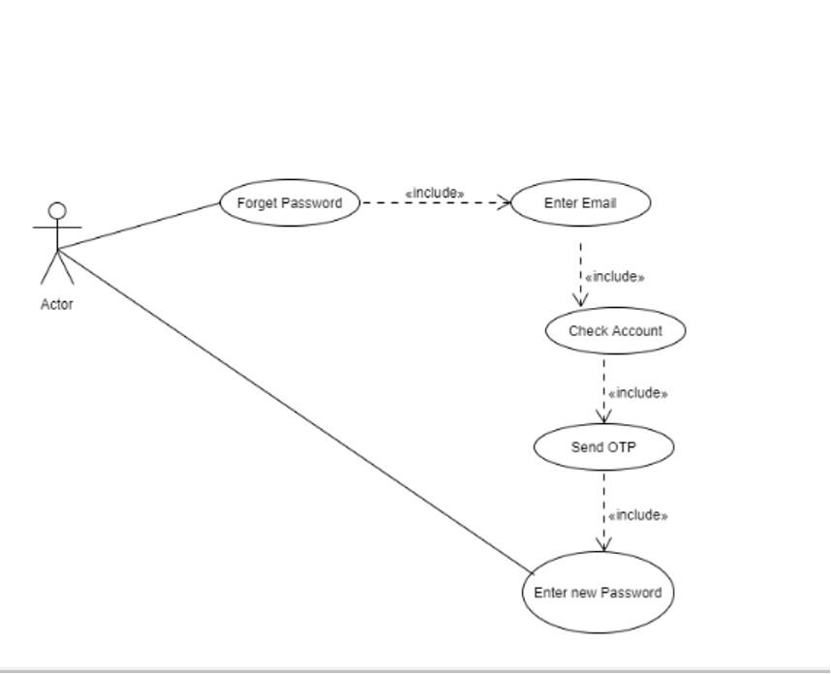

|  |  |
| --- | --- |
| Use Case name | **Add a user** |
| Related Requirements | Table 4 |
| Goal in context | User can add another user |
| Preconditions | The person who is adding has already added.  New user must be 18 or above.  New user must be is family member or friends. |
| Successful end Condition | New User successfully added |
| Failed End condition | Ads full description not posted, or ads is not showing on site. |
| Primary Actor | User |
| Secondary Actors | None |
| Trigger | Adding button will be clicked to add new user |
| Included Cases | Email Verification |
| Main flow | 1. Previous user add details of new user  2. Will provide credibility of new user and added them in their connection. |

|  |  |
| --- | --- |
| Use case name | **Account Settings** |
| Related requirements | Table 5 |
| Goal in context | User updates profile information successfully |
| Precondition | User should have an existing account and must be logged in |
| Successful End Condition | Update profile information including password |
| Failed End conditions | User’s profile information won’t be changed |
| Primary Actor | User |
| Secondary Actor | None |
| Triggers | Users clicks on the Account settings button |
| Included Cases | Verify password |
| Main Flow | 1. The user clicks the button for Account Settings 2. User is requested to enter their current password 3. The password is then verified by checking against the database 4. User has the option to update their profile information(Name, Password etc) 5. If the user updates their information, it’s updated in the database 6. Information updated successfully message will appear |

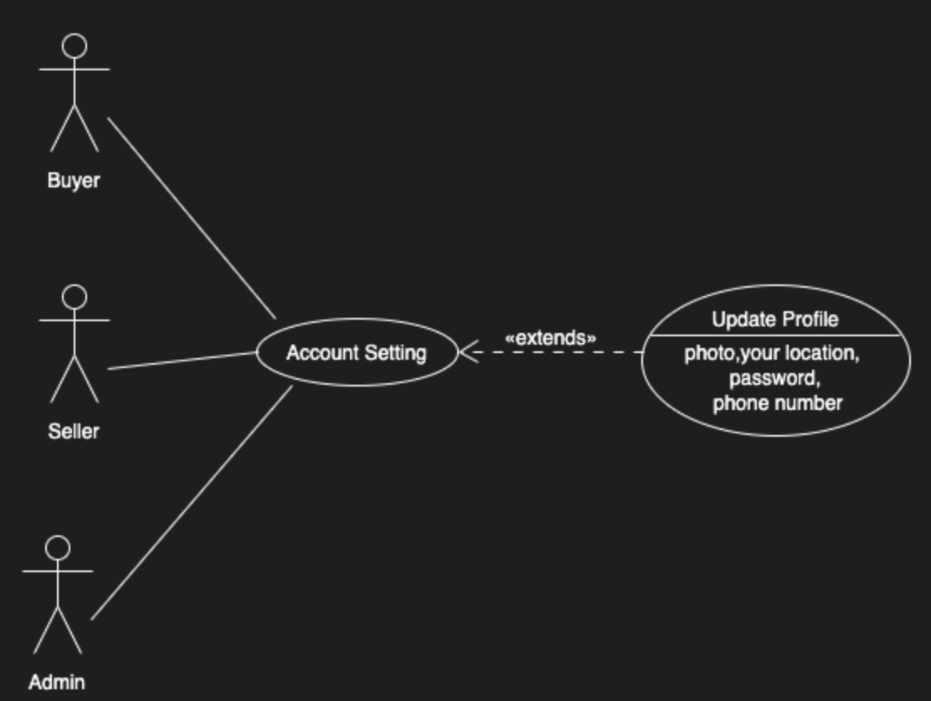

**4.3 System Feature 3**

**Detailed Product Categorization/ Search option**

4.3.1 Description and Priority

The system shall display detailed product categorization to the user. Specific model/ items that the user searches for should be displayed.

Priority: High

4.3.2 Stimulus/ Response

Stimulus: User selects a specific category such as electronics

Response: system will display all items that belong to electronics category

Stimulus: User searches for a specific item such as specific mobile type

Response: all ads that are about that particular mobile will be shown by different seller and price with all the description related to the product or if no product found the system should display “No Results found”.

4.3.3 Functional Requirements

Allow the buyers to have an option of manual searching the product.

Allow buyers to search through

|  |  |
| --- | --- |
| Use case name | **Viewing ads** |
| Related requirements | Sorting by credibility |
| Goal in context | Buyer can view products according to their rating based on the seller's credibility |
| Precondition | Buyer must be logged in |
| Successful End Condition | Products sorted credibility wise |
| Failed End conditions | Products sorted randomly |
| Primary Actor | Buyer |
| Secondary Actor | None |
| Triggers | Buyer selects a category to view |
| Included Cases | Sorting by credibility |
| Main Flow | 1. User opens app to view products 2. User selects the category of products 3. Products in the selected category appear sorted credibility wise automatically, with the top-rated products on top and poorly rated products towards the end. |

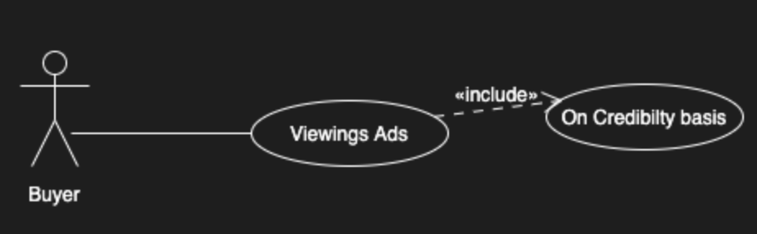

|  |  |
| --- | --- |
| Use Case name | **Searching by product** |
| Related Requirements | Table 6 |
| Goal in context | Specific product can be searched by name. |
| Preconditions | Buyer already exists.  Specified product should be added by seller. |
| Successful end Condition | Buyer can see products according to their search. |
| Failed End condition | No products shown related to the Search. |
| Primary Actor | User/Buyer |
| Secondary Actors | Seller |
| Trigger | Buyer can search by enter key or by search icon. |
| Included Cases | Login, Viewing ads. |
| Main flow | 1. Buyer logged in to the system. |
|  | 1. Buyer will search for the product. |
|  | 1. Will press enter or click search button. |
|  | 1. Specific products will be shown to buyer. 2. Or there can be no products posted or system error. |

|  |  |
| --- | --- |
| Use Case name | **View By Location** |
| Related Requirements | Table 7 |
| Goal in context | User can search the product by location |
| Preconditions | User already exists  Location is added by sellers add the time of product adding |
| Successful end Condition | Buyers can see product according to their preferred location. |
| Failed End condition | Products are not displayed according to their location |
| Primary Actor | Buyer |
| Secondary Actors | System, Database, Seller |
| Trigger | Buyers will have option to filter |
| Included Cases |  |
| Main flow | 1. Buyer will choose filtering category, which is location |
|  | 1. Will pressed the button |
|  | 1. Filtered products can be seen on screen |

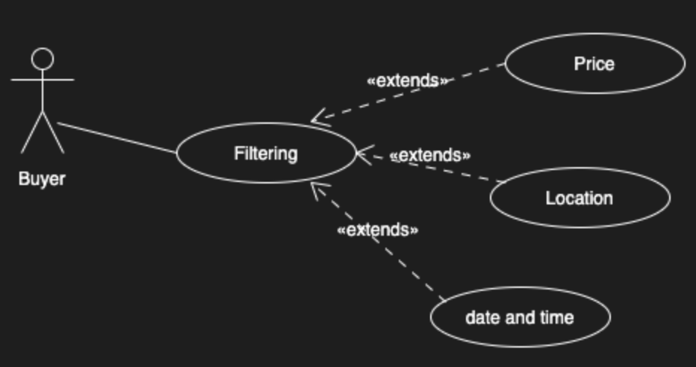

**4.4 System Feature 4**

**Provide customer support**

4.4.1Description and Priority

The system shall provide online help, FAQ’s customer support, and sitemap options for customer support.

Priority: Medium

4.4.2 Stimulus/ Response

Stimulus: user needs help in searching or using the website

Response: The system shall direct user to the FAQs page.

Stimulus: User needs help/ information on a particular product

Response: The system shall allow user to enter the customer and product information for the support and option for chat with admins will be available.

Stimulus: user have any complain regarding buyer/ seller

Response: Admins will tackle with any sort of complain and will take decision on whether to remove a user or not.

4.4.3 Functional Requirement

There will be a written documentation with pictures of user interface, which will help the user.

We will be going to add a page of FAQs where the user can take guidance of common questions.

User can take help by contacting our admin team, which is already trained

|  |  |
| --- | --- |
| Use Case name | **Complain** |
| Related Requirements | Table 8 |
| Goal in context | User can complain |
| Preconditions | Users are successfully login  Transaction completed if they want to complain about any buyer or seller |
| Successful end Condition | User can successfully posted complain to admin |
| Failed End condition | User cannot post the complain |
| Primary Actor | User |
| Secondary Actors | Admin |
| Trigger | Admin has received the complaint. |
| Included Cases |  |
| Main flow | 1. User can go to complain page |
|  | 1. User will have option how they want to complain such as by calling, email, or sending message |

|  |  |
| --- | --- |
| Use case name | **Review Complaint** |
| Related requirements |  |
| Goal in context | Admin reviews the complaint and takes action accordingly |
| Precondition | Admin must be logged in |
| Successful End Condition | An action is taken by the admin by reviewing the complaint |
| Failed End conditions | Complaints would keep piling up and no-one would review it |
| Primary Actor | Admin |
| Secondary Actor | Buyer/Seller |
| Triggers | Admin clicks on the review complaints button |
| Included Cases | A complaint should exist |
| Main Flow | 1. The admin must be logged-in 2. The admin clicks the review complaints button 3. If a complaint exists, the admin reviews it 4. The admin may now take an action depending upon the complaint. |

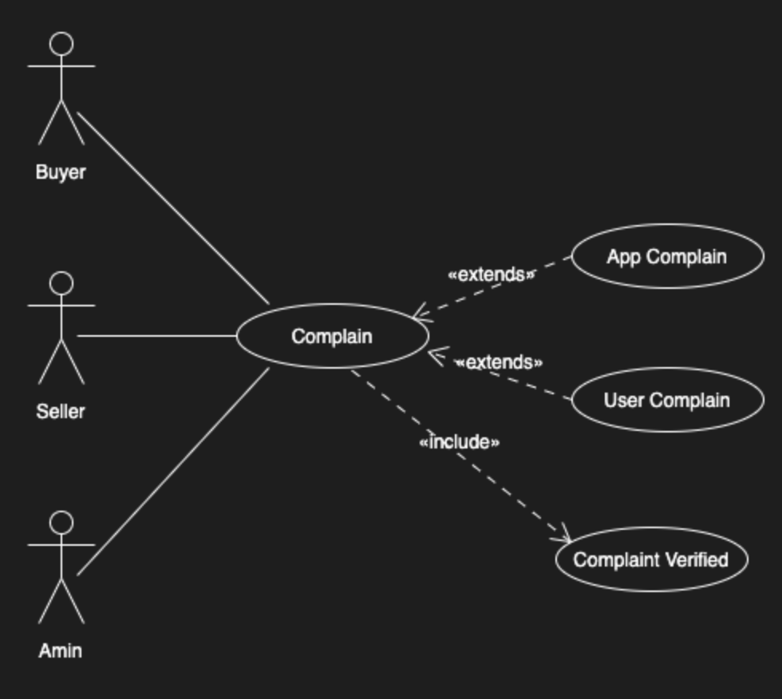

|  |  |
| --- | --- |
| Use Case name | **Remove User (Admin)** |
| Related Requirements | Table 9 |
| Goal in context | Admin removed User Account |
| Preconditions | Admin must be logged in  User already exists |
| Successful end Condition | Admin successfully Removed user account |
| Failed End condition | Admin unable to remover user account |
| Primary Actor | Admin |
| Secondary Actors | User |
| Trigger | Admin requests system to allow to remove the user |
| Included Cases |  |
| Main flow | 1. Admin logged in to the system |
|  | 1. Admin enters the ID of user which he/she want to delete |
|  | 1. Admin confirms the delete by pressing delete button |
|  | 1. Admin successfully removes the user |

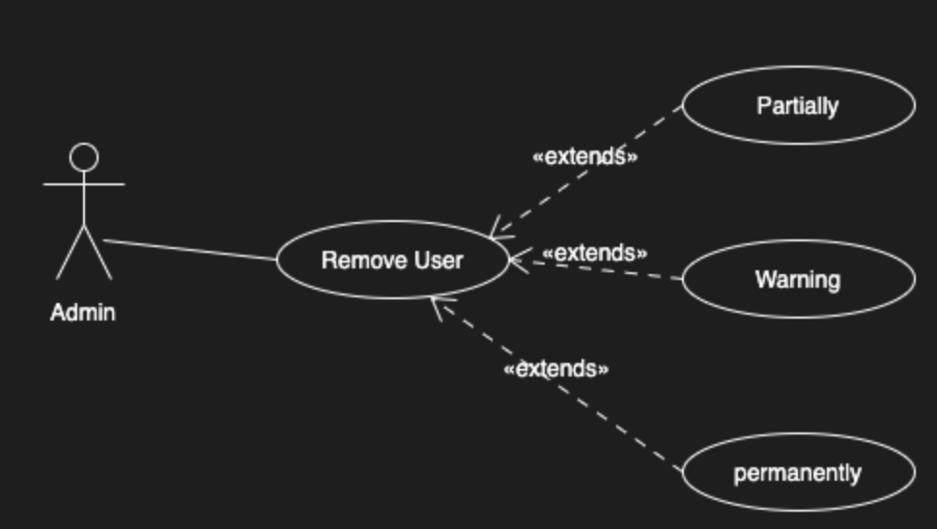

**4.5 System Feature 5**

**Chatting Page**

4.5.1 Description and Priority

This feature will allow the buyer to connect with the seller before buying anything. And helps the buyers to know seller and negotiate price.

Priority: Medium

4.4.2 Stimulus/ Response

There will be a pop-up window at the side of screen where they can communicate through each other. They can press the ‘send’ button to transfer message.

4.4.3 Functional Requirement

There will be option to send message only.

Buyer will have the option to put offer in the chat option.

Both side of user can see the option if another person has already ready message.

User can send images

User can send videos to each other

|  |  |
| --- | --- |
| Use Case name | **Chatting** |
| Related Requirements | Table 10 |
| Goal in context | Both, buyers and sellers, can chat with each other |
| Preconditions | Buyers have clicked on the product  Buyers have intention to buy the product |
| Successful end Condition | Both parties can communicate effectively. |
| Failed End condition | They cannot send or received message from another |
| Primary Actor | Buyer |
| Secondary Actors | Seller |
| Trigger | Chatting icon, which is clicked by user |
| Included Cases |  |
| Main flow | 1. User will click on the chatting icon at the bottom of the window |
|  | 2. User will have to option to message or post offer about the product   1. There will be option to bring image or video from your own device |
|  | 4. User will press the send button to transfer the message   1. Then we can close the window |

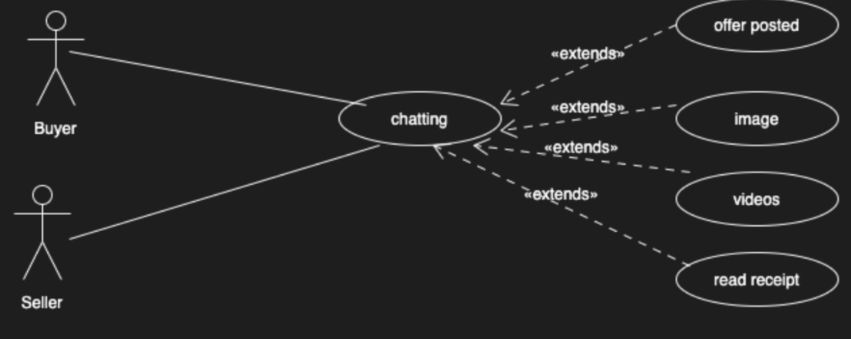

**4.6 System Feature 6**

**Credibility**

4.6.1Description and Priority

The application will provide the credibility of every person in the user seller’s list according to the size of chain of relation/nodes in between the potential user and increase/decrease credibility upon the response of seller’s product response by user/buyer.

Priority: High

4.6.2 Stimulus/ Response

Stimulus: User will add a person to the seller list by reference of someone or direct relation.

Response: The system algorithm will compute the seller’s credibility.

Stimulus: User responded to the purchased item of certain seller.

Response: The system will authenticate the response and then increase or decrease seller credibility according to certain criteria.

4.6.3 Functional Requirement

1. There should be a proper algorithm created to accurately compute the seller’s credibility in any scenario.
2. Application should authenticate the buyer’s response by any proof as false response can create discrepancies in computing real credibility.

|  |  |
| --- | --- |
| Use Case name | **Updating credibility** |
| Related Requirements | Table 11 |
| Goal in context | Giving credibility to the seller |
| Preconditions | Users must have an account  Transaction must have taken place |
| Successful end Condition | User has given credibility and it has been updated |
| Failed End condition | User couldn’t see updated credibility |
| Primary Actor | Buyer |
| Secondary Actors | Seller |
| Trigger | Update Credibility button |
| Included Cases |  |
| Main flow | 1. Confirmed that transaction has taken place |
|  | 1. Update credibility option will be given to user |
|  | 1. Credibility saved in database |
|  | 1. User can see the seller credibility list updated |

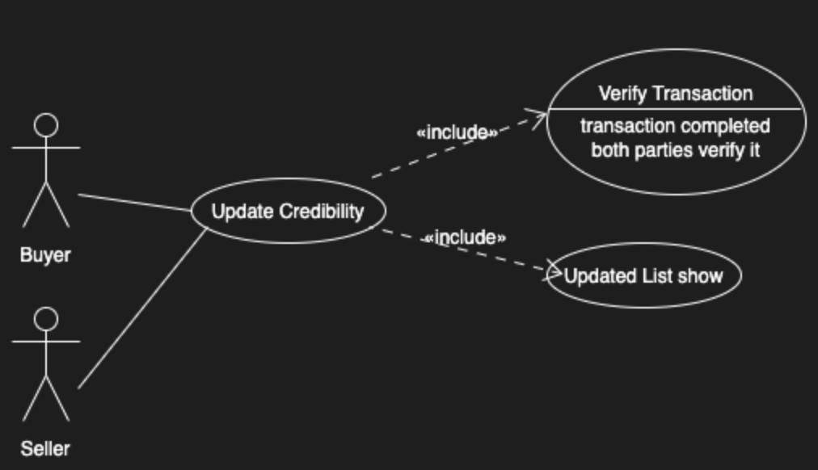

**4.7 System Features 7**

**Sorting by price**

4.7.1 Description and Priority

The System shall display prices sorted according to the user’s preference. It could be in ascending or descending order.

Priority: Medium

4.7.2 Stimulus/Response

Stimulus: User selects to display prices from low to high.

Response: System will display prices in ascending order.

Stimulus: User selects to display prices from high to low.

Response: System will display prices in descending order.

4.7.3 Functional Requirements

Allows users to choose how to sort their prices.

Allows them to pick if they want prices in ascending or descending order.

|  |  |
| --- | --- |
| Use Case name | **Sorting by Price** |
| Related Requirements | Table 12 |
| Goal in Context | Displays the prices of products in either ascending or descending order. |
| Preconditions | User has to be logged in. |
| Successful end conditions | Prices shown are in order. |
| Failed end condition | Unable to sort the prices/ Prices are in random order. |
| Primary Actors | Buyer |
| Secondary Actors | Seller |
| Trigger | Buyers will have an option to sort. |
| Included Cases | None |
| Main flow | |  |  | | --- | --- | | Steps | Actions | | 1  **Extends:**  **Viewing ads** | User will see ads. | | 2 | User can choose to sort the ads in order of their price. | | 3 | System displays all the ads in order | |

**4.8 System Features 8**

**Posting/ Deleting an Ad**

4.7.1 Description and Priority

The user should be able upload and delete an ad after verification of the system.

Priority: High

4.7.2 Stimulus/Response

Stimulus: User selects to post an ad.

Response: System will ask the user to add the relevant details about the product.

Stimulus: User will ask to upload all the post.

Response: System will upload after confirming with the user.

Stimulus: User will ask to delete an ad.

Response: system will delete the ad after confirming with the user.

4.7.3 Functional Requirements

Allows users to Upload / delete an ad.

|  |  |
| --- | --- |
| Use Case Name | **Product Listing** |
| Related Requirements | Table 13 |
| Goal in Context | Sellers can post or delete an ad |
| Precondition | User have to login before posting/ deleting |
| Successful End Condition | Ad uploaded/ deleted successfully |
| Failed End Condition | Unable to upload/ Error in uploading the ad |
| Primary Actor | Seller |
| Secondary Actor | None |
| Trigger |  |
| Included Cases | User Login |
| Main Flow | |  |  | | --- | --- | | Steps | Actions | | 1 | User clicks on option to post/delete the ad | | 2  **Include: Login** | System asks the user to login/ signup to post | | 3 | User will upload all the related documents and fill and the details of the product | | 4 | System will verify the details upload the ad successfully | | 5 | User will choose an option to delete the ad | | 6 | System will delete the ad successfully | |

# Other Nonfunctional Requirements

## Performance Requirements

* The homepage should load in no more than 5-6 seconds on iOS. 7-8 second on android and 9-10 seconds on windows. users time is important, you don’t want to make them feel like its not worth their time.
* Sorting on the bases of prices of a product.
* User can see what are the trending searches for items.
* Products divided in categories to help ease the searching.
* Location option to search for a product within a city or other city.
* User can sort the ads by date and time.
* Sellers can send media in the chat.
* Buyers can put offers for a particular ad to sellers that will be put up in chat.

## Safety Requirements

* Backup for the database should be created incase if it crashes because of the load or a virus.
* Product verification before listing it on the site to avoid duplication and illegal products on system.
* User verification by OTP sent on the email they listed to avoid fraudulent activity.

## Security Requirements

* Your registration information is protected by unique username and a password. You should not share these details with someone else and you should remember to log off when using a shared computer.
* System will use secure database to avoid data loss and virus/hacking attempts.
* The software cannot be accessible anonymously without making an account.
* Ip addresses check to avoid online fraud.
* Seller or buyers' location is kept hidden unless they share when a deal has been made.

## Software Quality Attributes

* The admin will have the right to create changes to the system.
* Seller can only edit information and mark the product as sold on the products they listed.
* Database quality is maintained to be user friendly to all users to ease the seraching.
* The users should be able to easily create an account and list their product.
* A customer should easily find the right product for them, understand what problems it solves, and make a purchase without contacting us.
* The software can be easily expanded and will be adaptive to changes.

## Business Rules

* System admin can assign roles and change access permissions.
* Only Sellers can mark their product as sold, which will be removed from the available list.
* Understanding customer behavior: Admin can use real time analytics tools to see how visitors move about the page to detect any suspicious activity.
* Neither the admin nor users should cross the rules and regulations.
* Buyers can use the complaint section to lodge a complaint for a possible fraudulent activity.

# Other Requirements

* The software will be reliable as using worst case scenarios and process controls will cut short the implications.
* The software will be application compatible with every type of user to avoid disparity.
* The software can be re-used as it will be open for future changes.
* Sellers will have an option to copy the invite link and share on their social media platform.
* Software will have copyright rule.
* Skillful team required to check database and application

Appendix A: Glossary

**User/End User:** People who will be using the system to buy/sell.

**CLS:** Common Language Specification – document to specify how computer programs can be turned into common intermediate language code for cross-language compatibility under a common framework such as Microsoft’s .NET.

**SRS:** Software Requirement Specification – document to specify the requirements, functionalities and other matters relating relevant stakeholders’ needs within the software product.

**GUI:** Graphical User Interface – type of interface to enable interaction between a software system and user(s) with the aid of representative graphical indicators, icons etc.

**Stakeholders:** Individuals or groups of people directly or indirectly involved in a software project, e.g., the client(s), the developer(s), the target audience(s), end user(s).

**FTP**: File Transfer Protocol – set of rules governing the transfer of file objects between computers. Usually use lossy compression and decompression; modern FTP rules enable lossless data transfer and handle data integrity relatively better.

**HTTP**: Hyper Text Transfer Protocol – communications protocol to define the rules governing the transfer of files and webpages over the web. HTTP protocols are usually lossless.

**OTP**: One-Time Password which is send from the system to the user on email or SMS to verify them.

**2-step Confirmation**: it is done to confirm about the task from user 2 times, to avoid by-mistake

**Functional Requirements:** what the system does or don’t do.

**Non-functional Requirements:** how the system should do.

**Stimulus/Response Sequence:** the actions performed by the user and what they received from that actions or tasks.

Appendix B: Analysis Models

<Optionally, include any pertinent analysis models, such as data flow diagrams, class diagrams, state-transition diagrams, or entity-relationship diagrams.>

Appendix C: To Be Determined List

* **Paid advertise:** Sellers can feature their add by paying for ads so they will come on top.
* **Artificial intelligence:**  Based on buyer interest according to his past search history the list of relevant items will show to him/her in home or if he/she searches for any other products. .
* **SignUp using social media**: will allow the user to add someone through their social media as most people have friends and family members already on social media.